**JOB WORK SERVICES**

**IT138 Vishnu Sanariya-19ITUOS024**

**IT150 Sahil Sheta-19ITUOS024**

1. First download ZIP file or clone from this repository:

<https://github.com/SAHILSHETA1606/JOBWORK-SERVICES---SDP-PROJECT.git>

1. Locate the directory where manage.py is available

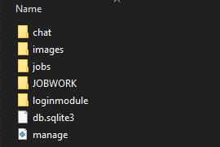

1. From this directory open the command prompt or open VS CODE or PYCHARM from directory

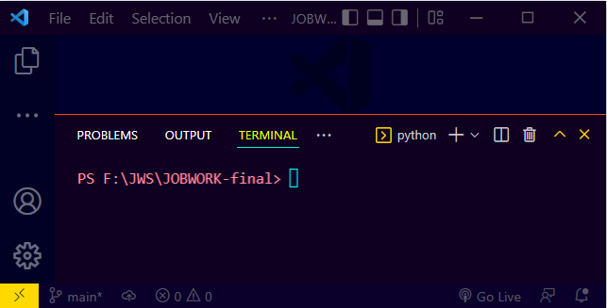

NOTE: make sure cdevice is already up to date with python latest verson or install it before running this command in this case we are dealing with images ,it’ll requires python pillow library

Command: pip install pillow

1. Then run this command : python manage.py runserver

Wait till command is completes its execution

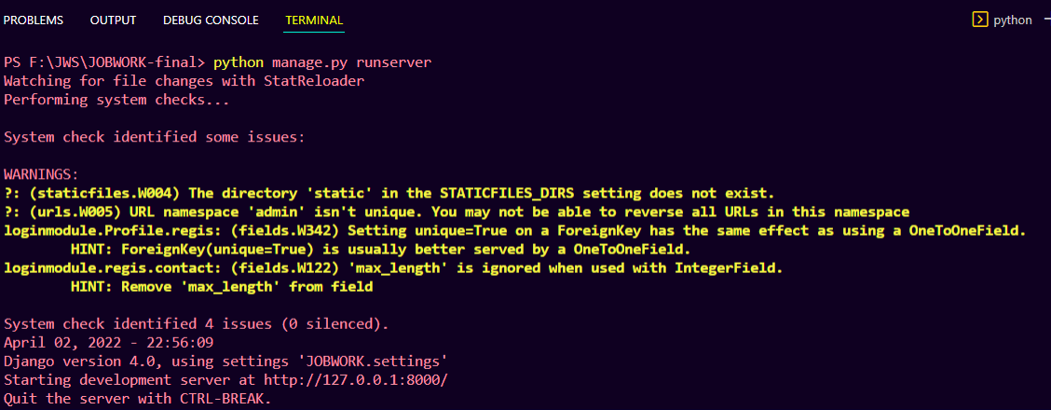

NOTE: make sure you are connected to the active internet so that bootstrap and all cdn link works properly in case of it is not working properly kindly goto the browser setting and clear the cookies and cache data.

1. Simply click on the link <http://127.0.0.1:8000/> or got the browser and paste it in search bar

**THANK YOU!!**